85Install nginx and run nginx on port number 81.
Search nginx.org on browser
Click on documentation on the right side of the screen
Click on the download option o the second line on the left side of the screen
Then extract the downloaded file in the C- disc
And run the nginx from the folder and search localhost in the browser and you will see this page.
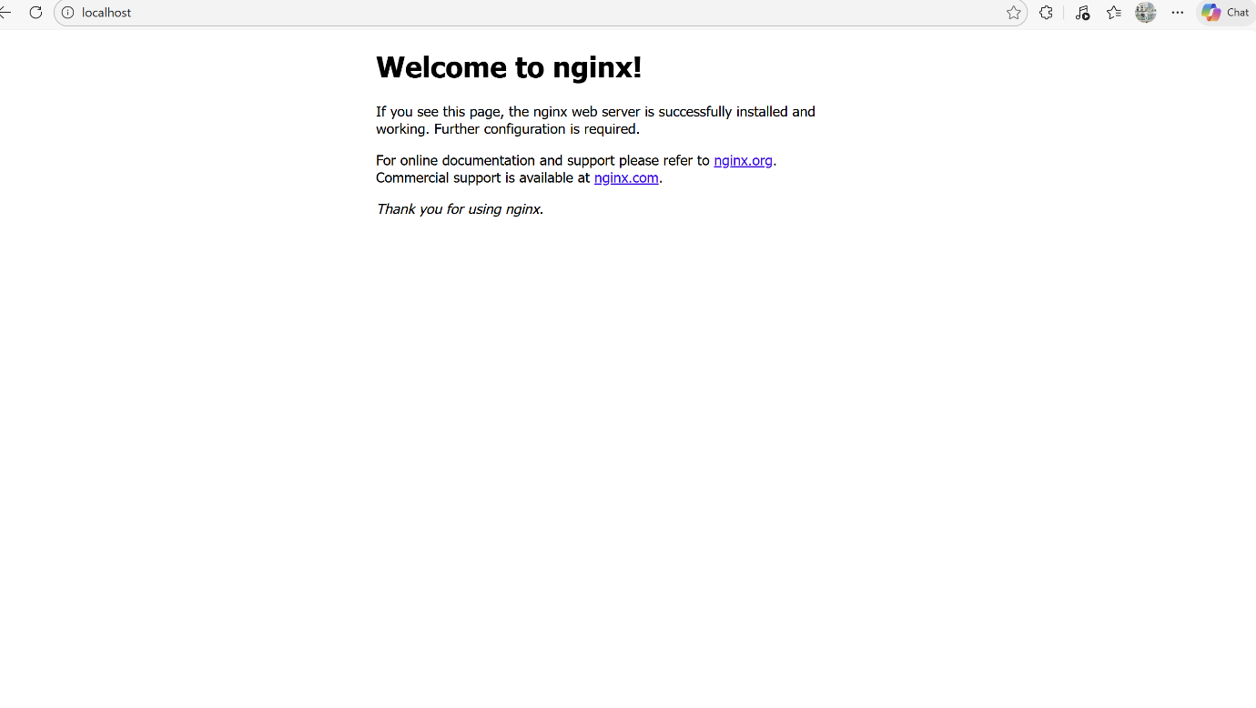

Deploy a sample index.html file on nginx.



Install Apache and run Apache on port number 82
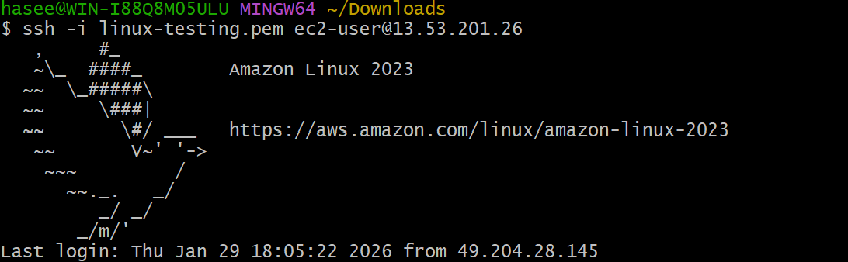
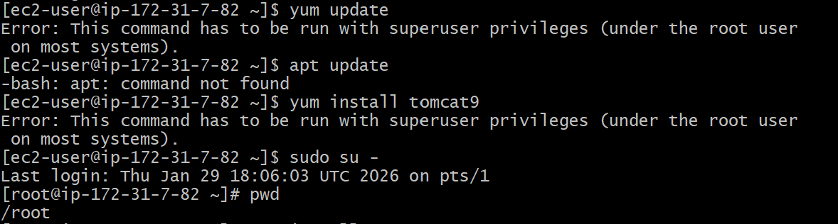
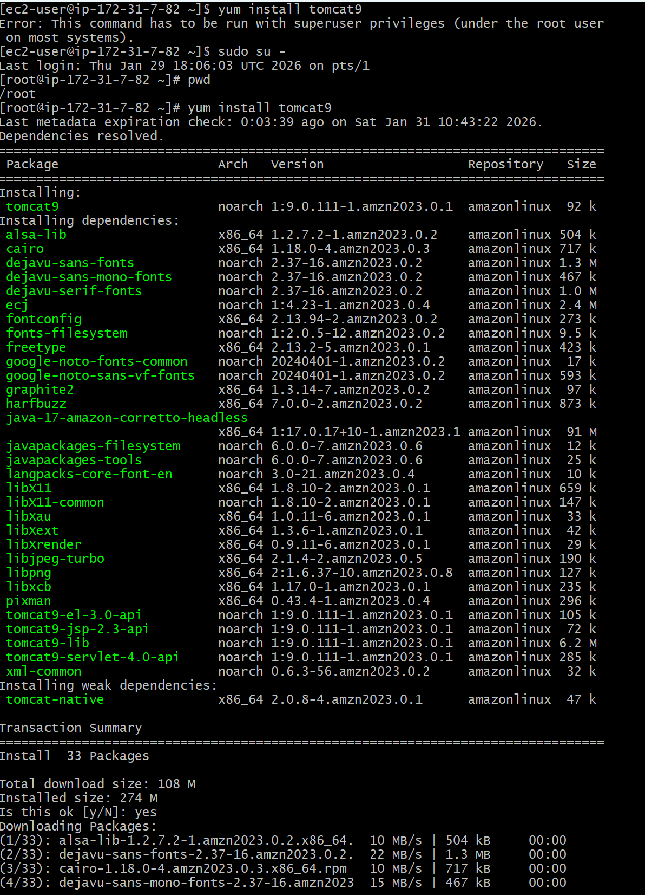
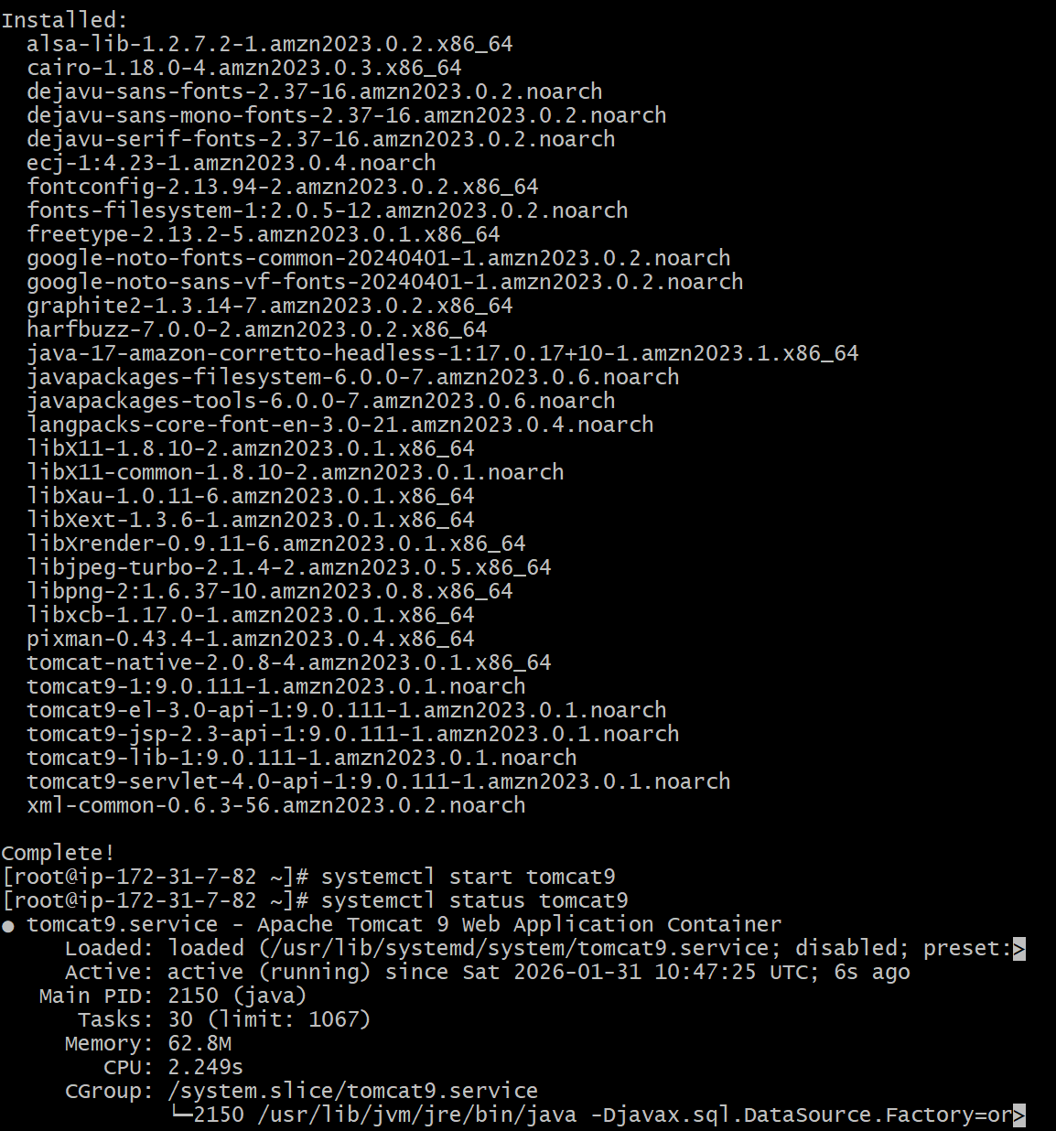
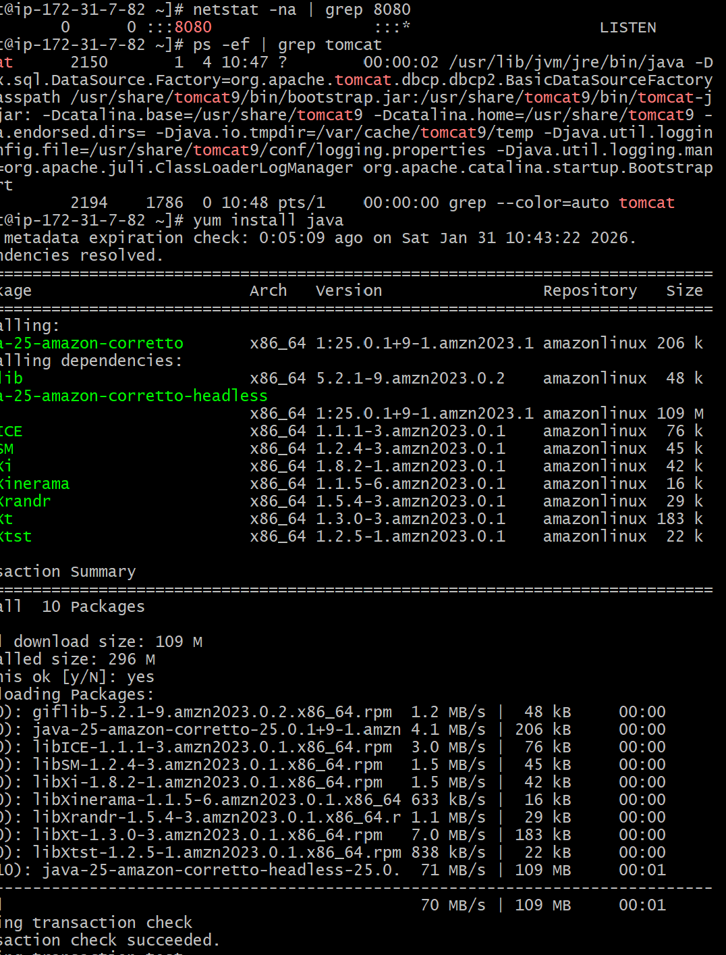
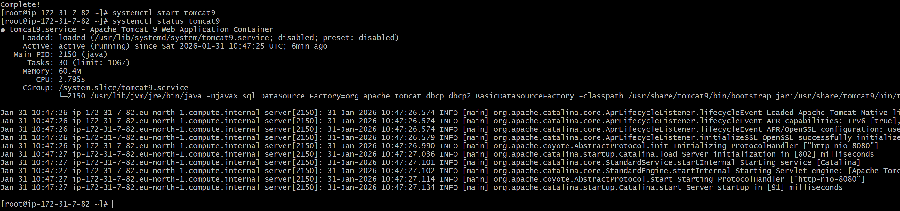

Deploy a sample index.html file on Apache.
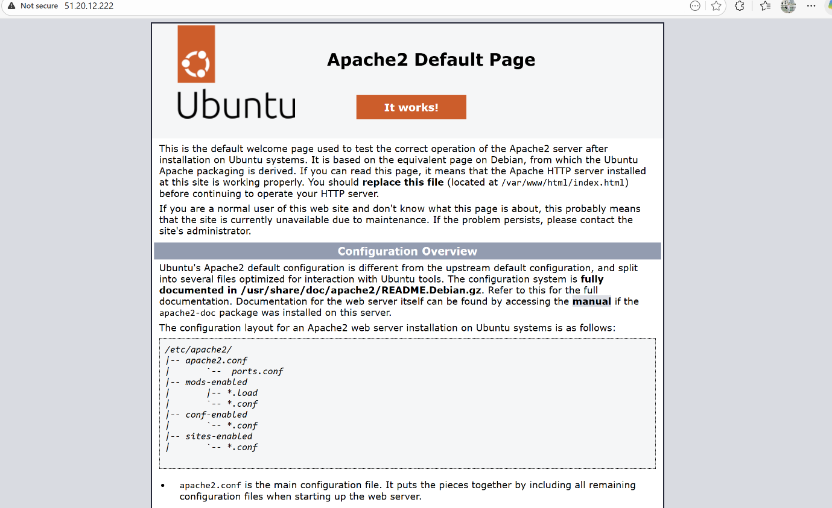
Deploy a sample index.html file on Apache.
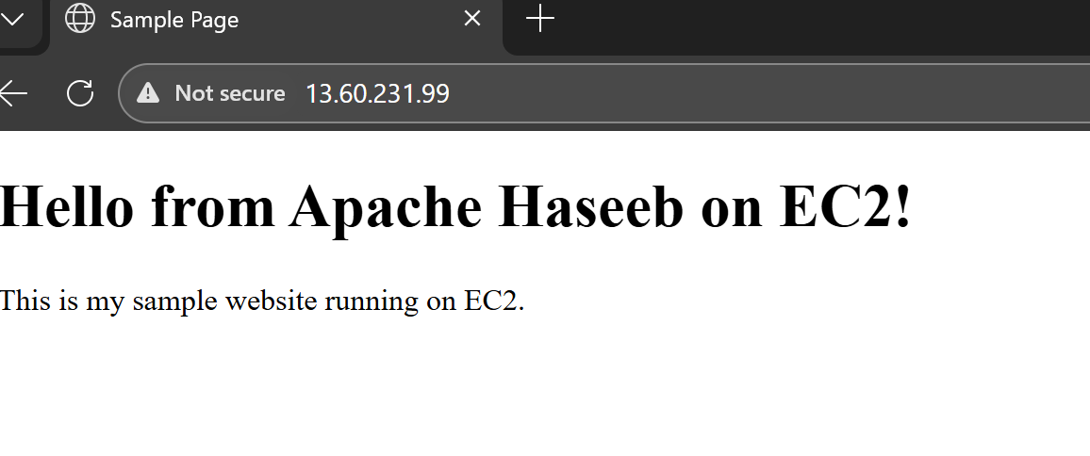
Install Apache tomcat on port number 8082

Deploy a sample app on webappsDeploy a sample app on webapps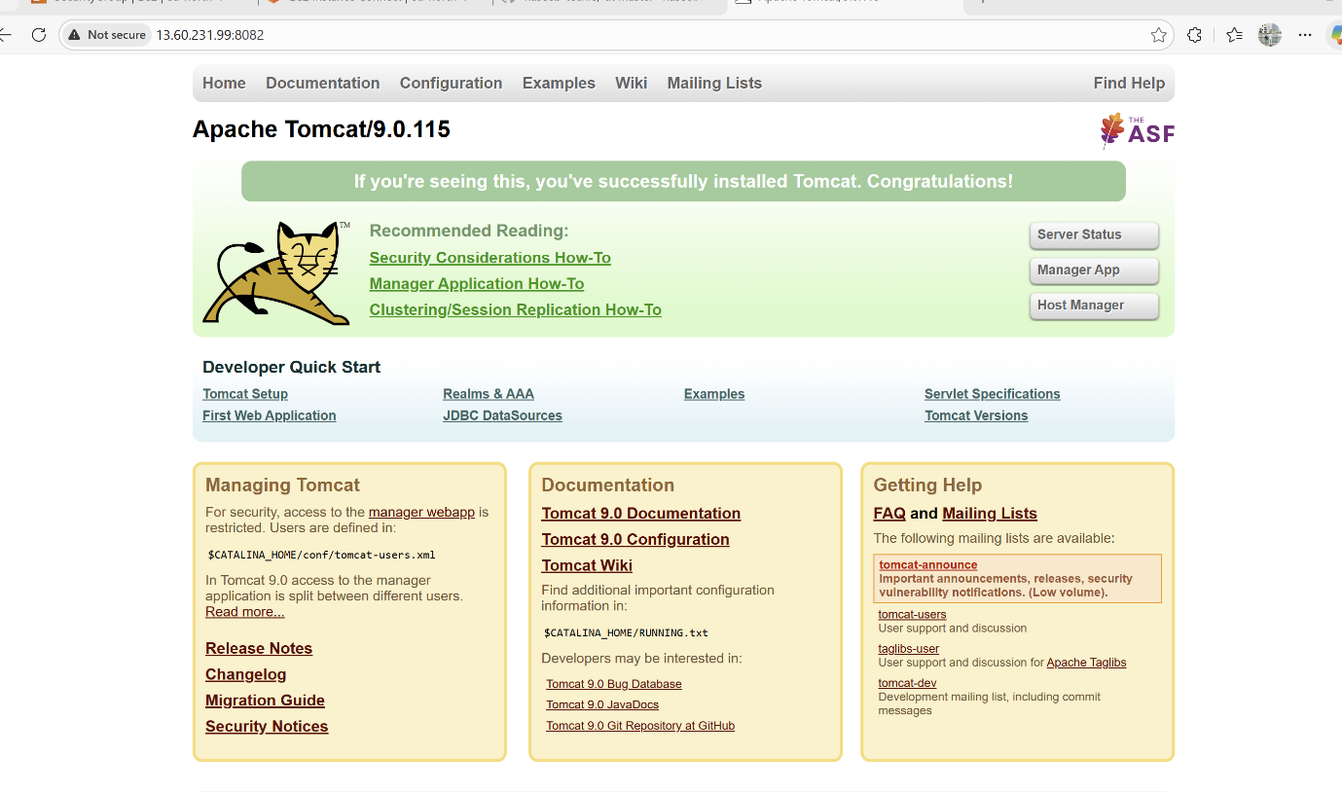
Deploy a sample app on webapps
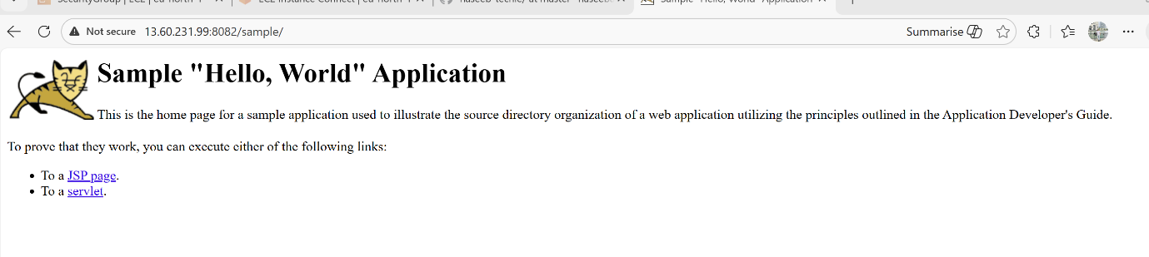
Create a tomcat.service file for tomcat.
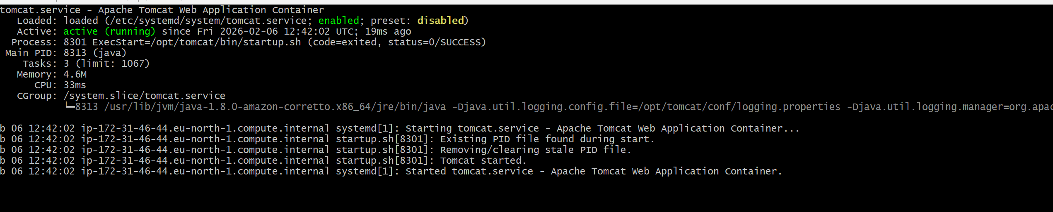
Configure HA Proxy server
